# **Deploy Web Application on Tomcat Web Server**

**Steps To Deploy Web Application:**

1. Stop Tomcat service.



1. Download Tomcat sample application war file [here](https://tomcat.apache.org/tomcat-7.0-doc/appdev/sample/sample.war).



1. For Windows, go to "C:\Program Files\Apache Software Foundation\Tomcat 9.0\webapps". For Linux, go to "/opt/tomcat9/webapps" .
2. Remove everything inside the folder.

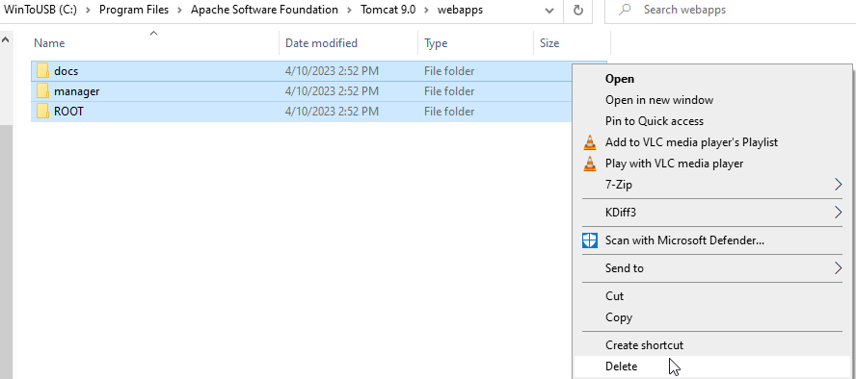

1. Copy and paste sample.war file to webapps folder.

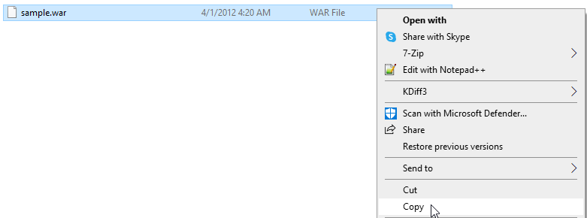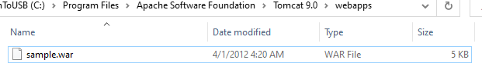

1. Start Tomcat service.



1. To access sample web, go to http://127.0.0.1:8080/sample . If the sample page open, you already successfully deploy war file. Congratulation.

